**PROJECT REPORT**

**UNVEILING MARKET INSIGHTS; ANALYSING SPENDING BEHAVIOUR AND IDENTIFYING O9PPORTUNITIES FOR GROWTH**

**NM ID:NM2023TMID14264**

1.INTRODUCTION

1.1 Overview

Marketing makes use of the “Marketing mix” also known as the four Ps-Product, price, place, and promotion.

1.2 Purpose

A marketing proposal is a document provided to key stakeholders to communicate the scope of a marketing project and its budget.

2.PROBLEM DEFINITION & DESIGN THINKING

2.1 Empathy Map

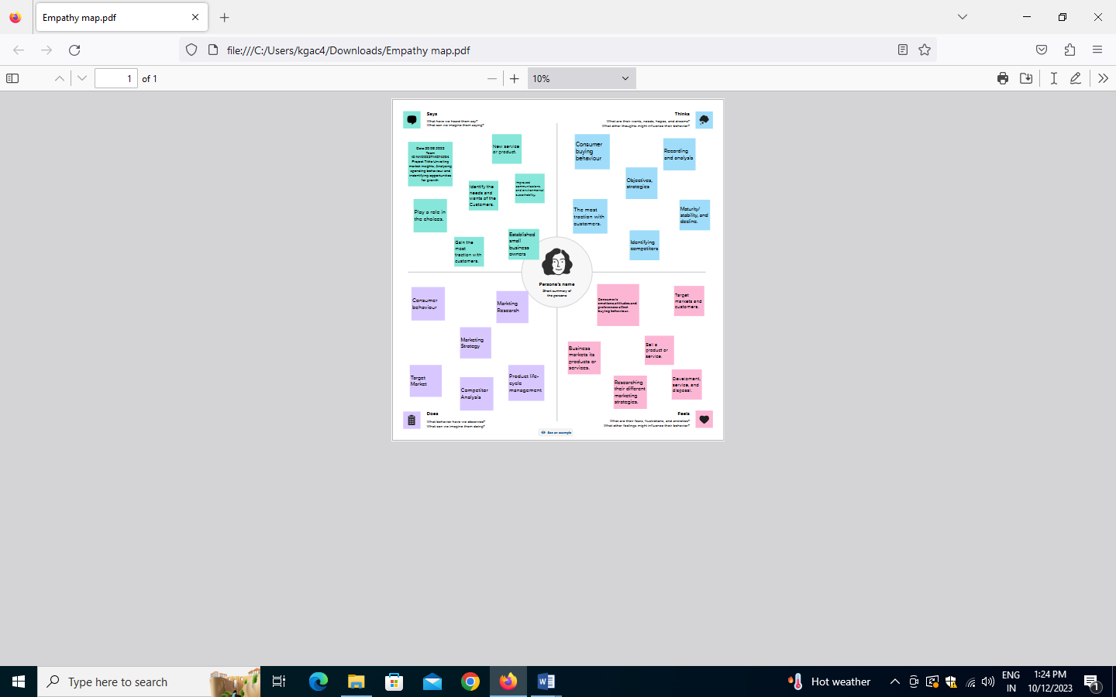

2.2 Ideation & Brainstorming Map

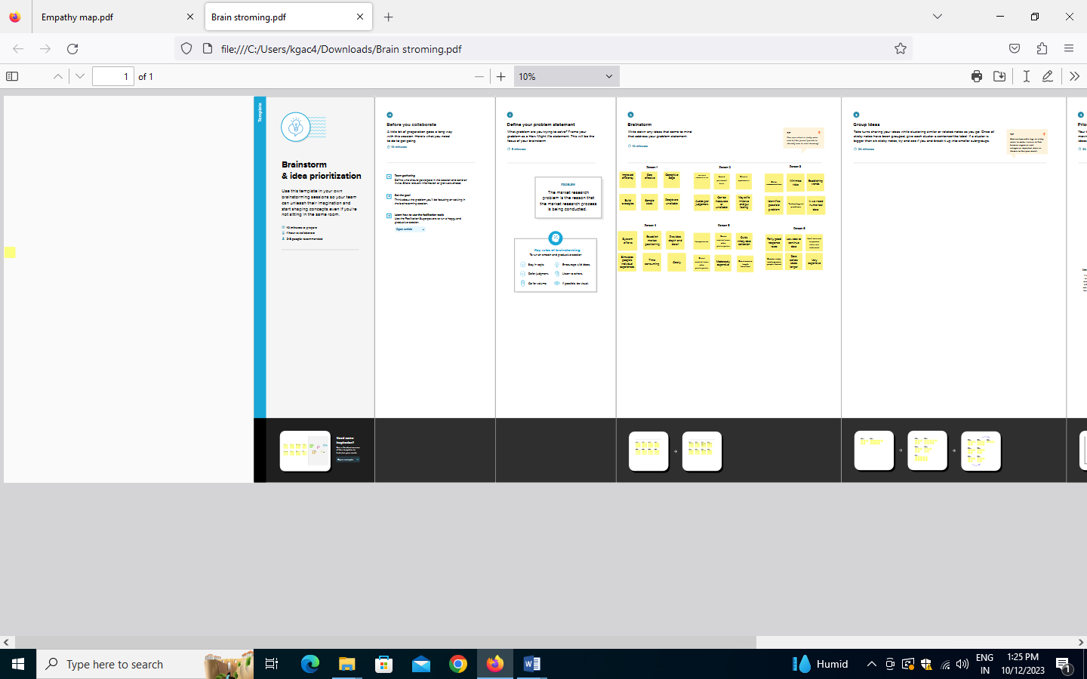

3.RESULT

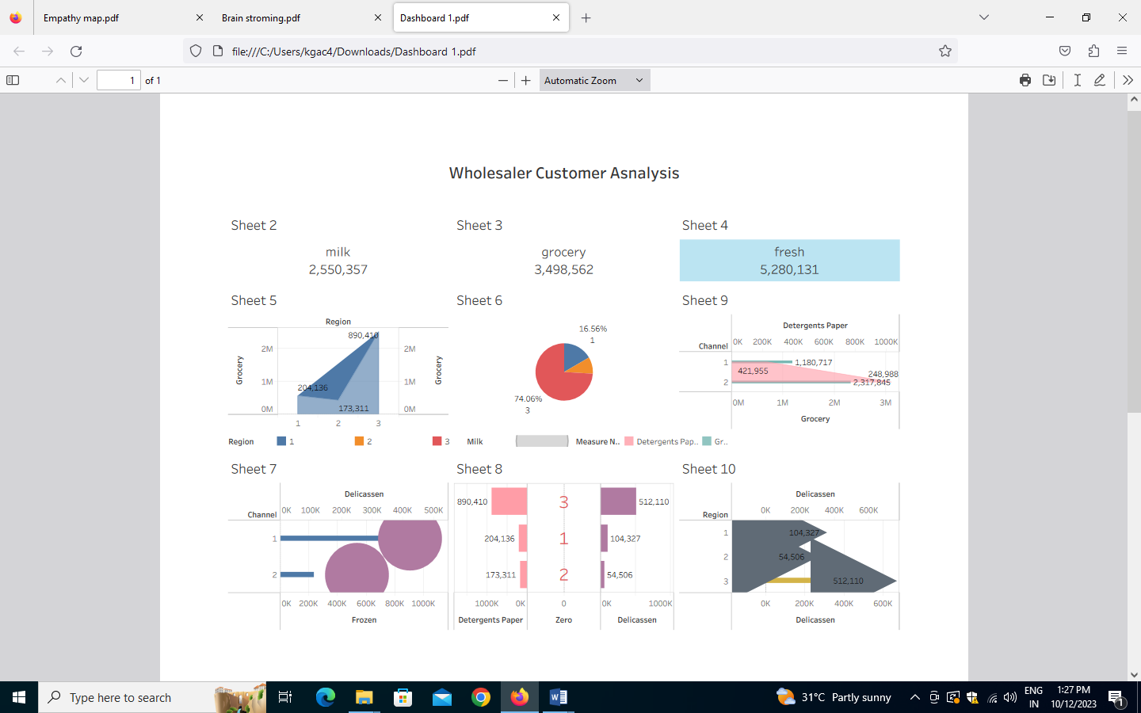

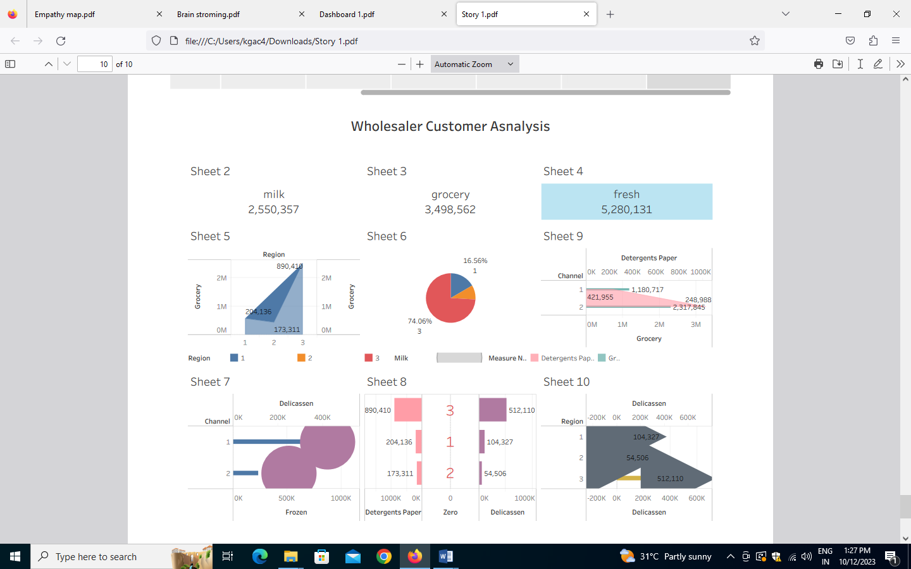

4.ADVANTAGES & DISADVANTAGES

*Lower Outreach Costs

*Less Competition

*More Loyal Customers

*Very Small Size

*Less Loyal Customers

*The Audience Is Too Wide

5.APPLICATIONS

Marketing apps are the tools that provide a marketing strategy with the right conditions to achieve its goals. Some of the most common examples of these applications relate to data analysis.

6.CONCLUSION

A conclusion of a project report on market research should summarize the key findings and insights from the research.

7.FUTURE SCOPE

Consequently, the overall employment of marketing managers is projected to grow 10% from 2021 to 2031.

8.APPENDIX

A.Source Code

Marketing source codes uniquely identify a specific marketing ad within a campaign or category.